2. Write a Shell Script to find maximum between three numbers.
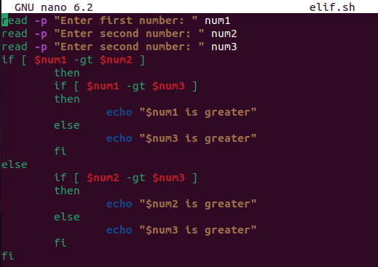
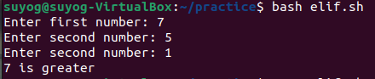

3. Write a Shell Script to check whether a number is negative, positive or zero.
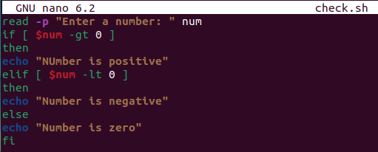
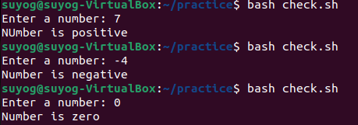

4. Write a Shell Script to check whether a number is divisible by 5 and 11 or not.
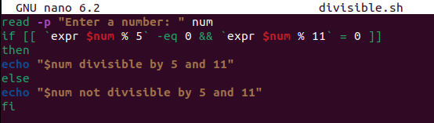
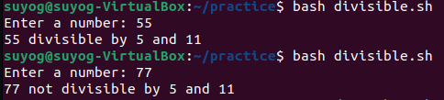
5. Write a Shell Script to check whether a number is even or odd.
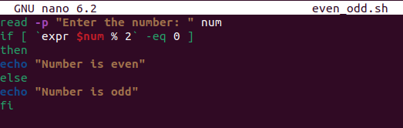
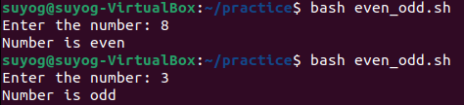
6. Write a Shell Script to check whether a year is leap year or not.
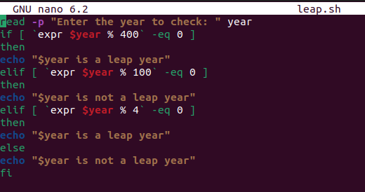
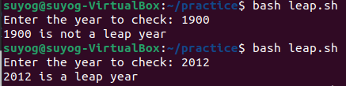
7. Shell Script to print number between 1 to 10 in character format using switch-case.
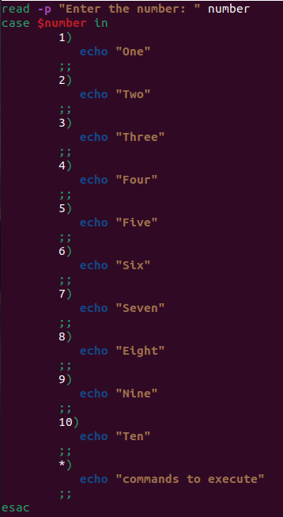
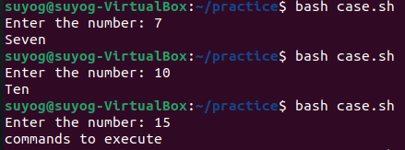

8. Shell Script to accept id from user to confirm department using switch-case.
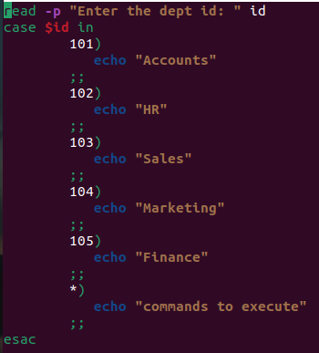
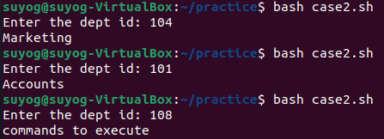
10. Shell Script to print day of week using switch-case.
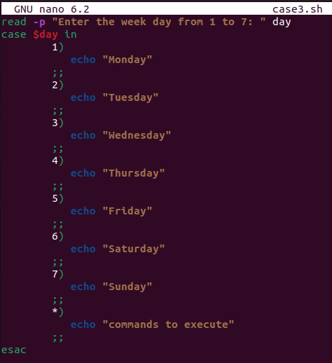

- Write a Shell Script to find maximum between two numbers.
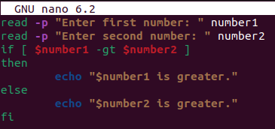
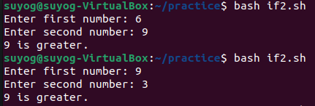

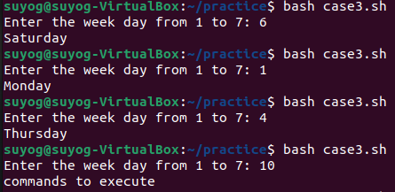
11. Shell Script to create calculator using switch-case.
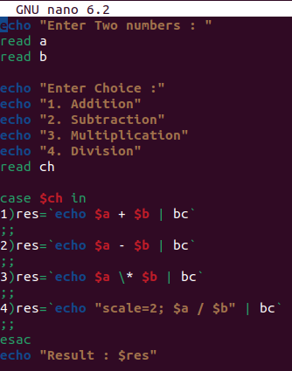

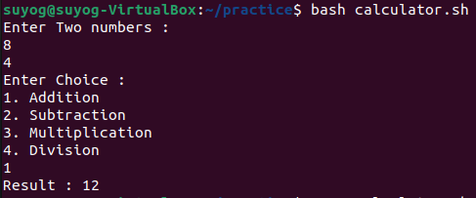
1. Shell Script to display the first 10 natural numbers.
Expected Output :
1 2 3 4 5 6 7 8 9 10
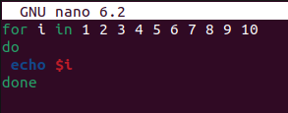
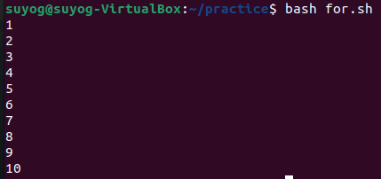
2. Shell Script to compute the sum of the first 10 natural numbers.
Expected Output :
The first 10 natural number is :
1 2 3 4 5 6 7 8 9 10
The Sum is : 55
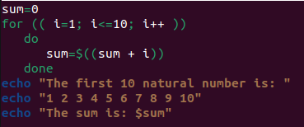
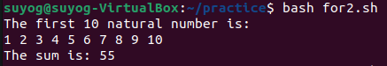
3. Shell Script to display n terms of natural numbers and their sum.
Test Data : 7
Expected Output :
The first 7 natural number is :
1 2 3 4 5 6 7
The Sum of Natural Number upto 7 terms : 28
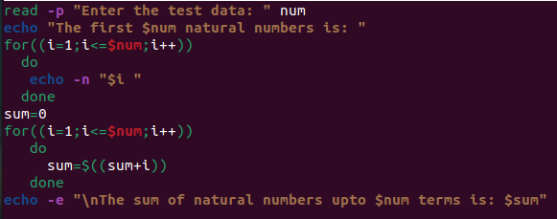
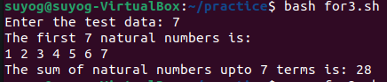
4. Shell Script to read 10 numbers from the keyboard and find their sum and average.
Test Data :
Input the 10 numbers :
Number-1 :2
...
Number-10 :2
Expected Output :
The sum of 10 no is : 55
The Average is : 5.500000
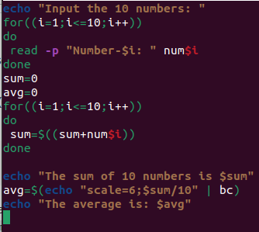
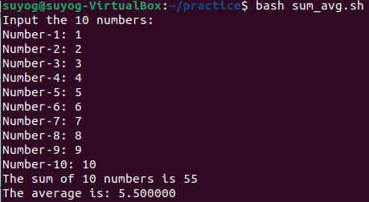
5. Shell Script to display the cube of the number up to an integer.
Test Data :
Input number of terms : 5
Expected Output :
Number is : 1 and cube of the 1 is :1
Number is : 2 and cube of the 2 is :8
Number is : 3 and cube of the 3 is :27
Number is : 4 and cube of the 4 is :64
Number is : 5 and cube of the 5 is :125
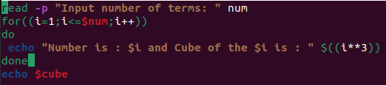
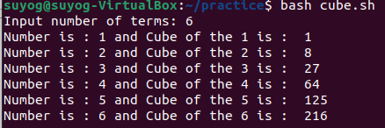
6. Shell Script to display the multiplication table for a given integer.
Test Data :
Input the number (Table to be calculated) : 15
Expected Output :
15 X 1 = 15
...
...
15 X 10 = 150
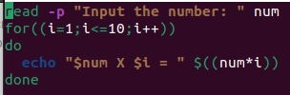
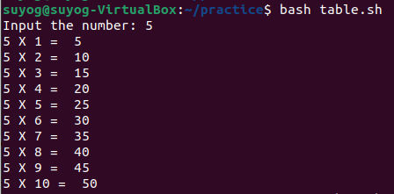
7. Shell Script to display the multiplier table vertically from 1 to n.
Test Data :
Input upto the table number starting from 1 : 8
Expected Output :
Multiplication table from 1 to 8
1x1 = 1, 2x1 = 2, 3x1 = 3, 4x1 = 4, 5x1 = 5, 6x1 = 6, 7x1 = 7, 8x1 = 8
...
1x10 = 10, 2x10 = 20, 3x10 = 30, 4x10 = 40, 5x10 = 50, 6x10 = 60, 7x10 = 70, 8x10 = 80
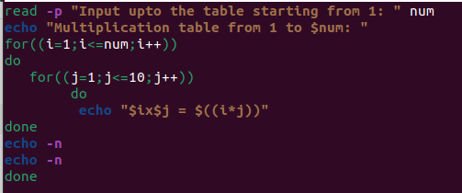
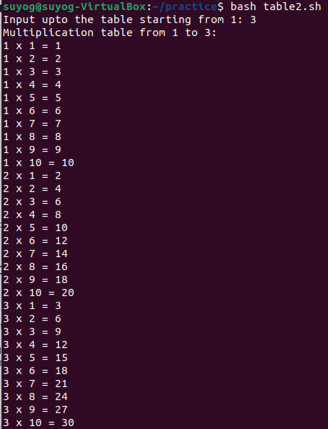
8. Shell Script to display the n terms of odd natural numbers and their sum.
Test Data
Input number of terms : 10
Expected Output :
The odd numbers are :1 3 5 7 9 11 13 15 17 19
The Sum of odd Natural Number upto 10 terms : 100
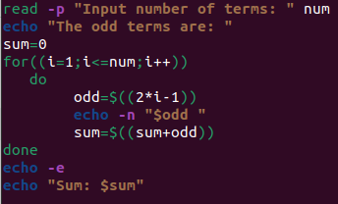
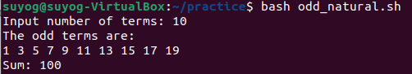
9. Shell Script to display a pattern like a right angle triangle using an asterisk.
The pattern like :
*
**
***
****
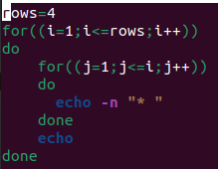
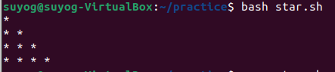
10. Shell Script to display a pattern like a right angle triangle with a number.
The pattern like :
1
12
123
1234
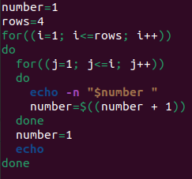
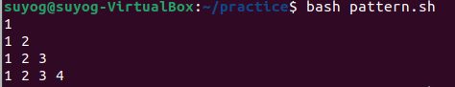
11. Shell Script to make such a pattern like a right angle triangle with a number which will repeat a number in a row.
The pattern like :
1
22
333
4444
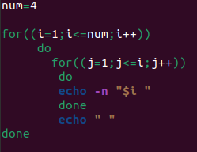
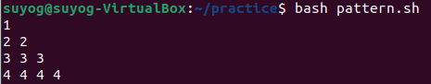
12. Shell Script to make such a pattern like a right angle triangle with the number increased by 1.
The pattern like :

1
2 3
4 5 6
7 8 9 10
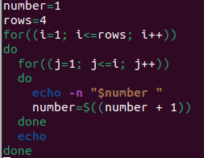
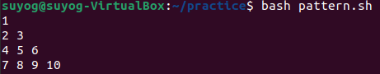
1. In your home directory, create sets of empty practice files
- Create 6 files with names of the form songsX.mp3.
- Create 6 files with names of the form snapX.jpg.
- Create 6 files with names of the form filmX.avi.
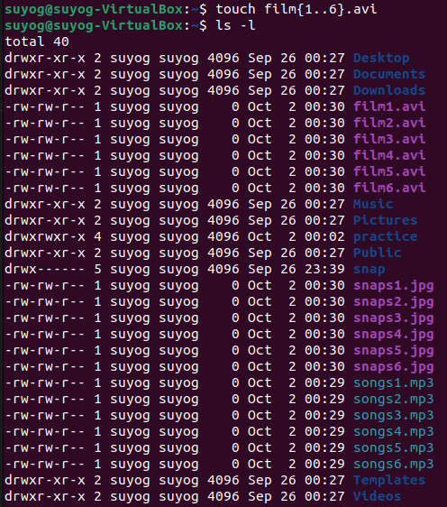
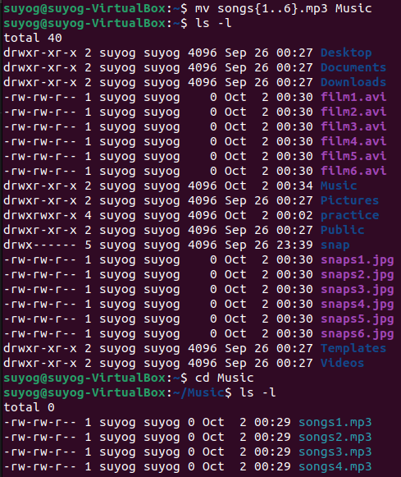
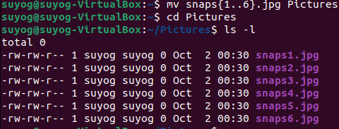
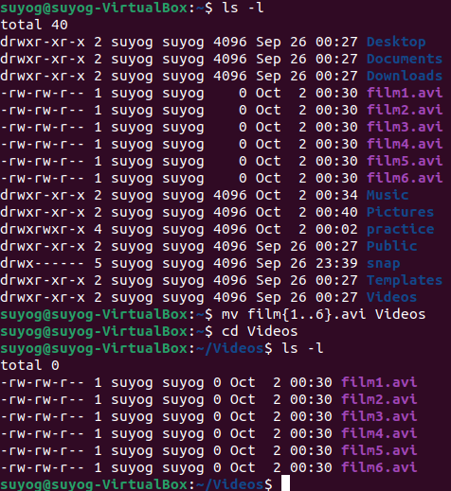

3. Create 3 subdirectories for organizing your files named fricd.ends,family,work
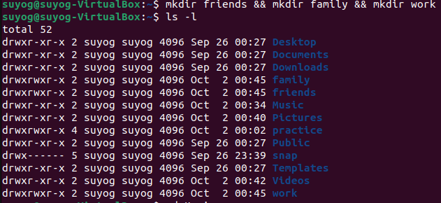
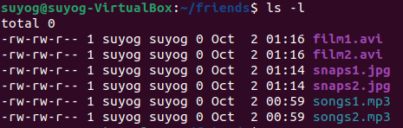
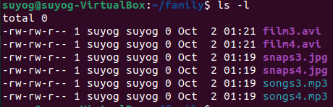
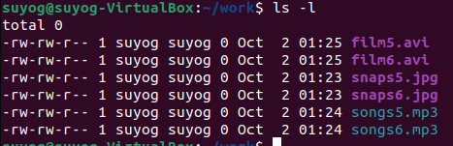

6. Delete all files in family subdirectory
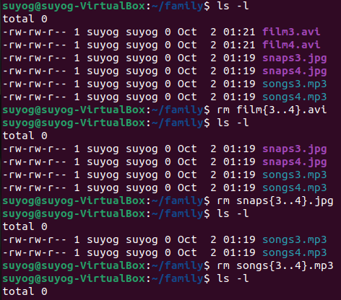
7. Delete friends subdirectory
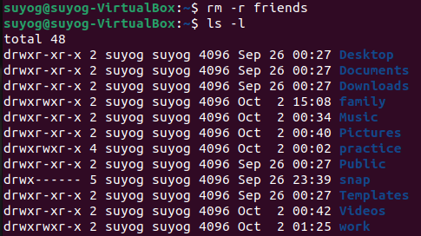
8. Create user tom , bob , sam , prince
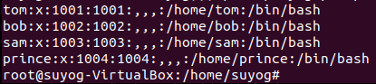
9. Create Group dac , dbda ,ditiss
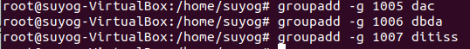
10. add user

Tom in dac
Bob in dbda
Sam in ditiss
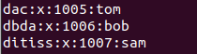
11. login as prince and create iacsd directory in /tmp and create 4 files in iacsd with name project-1 project-2 upto 4
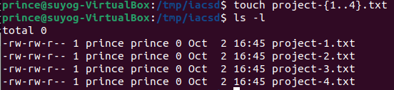
12. assign permissions to project files as below
Project-1 – tom should be owner of this
Project-2 – dac should be owner of this
Project-3 --- others should not have any permission but tom should have rw access
Project-4 – dbda group should have rwx permissions.
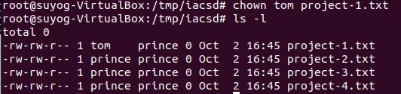
1) Write a shell script tp print
- your are logged in as which user
- in which directory you are
- and in which terminal you are working
- total number of files and directories in current directory
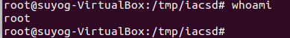
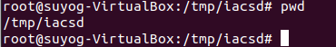
3) Write a Linux shell script to accept 10 number and tell how many are +tive, -tive and zero.
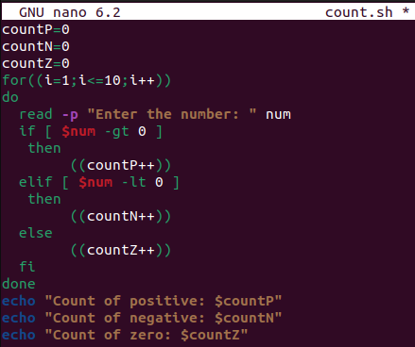

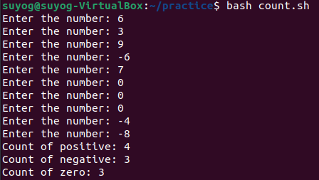
4) Write a shell script to accept five number and display max and min value.
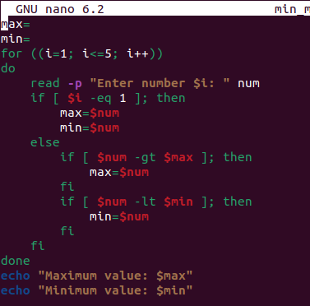

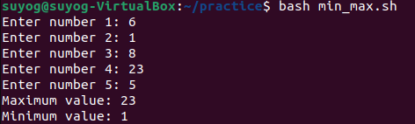
5) Write a script to find out String is palindrome or not.
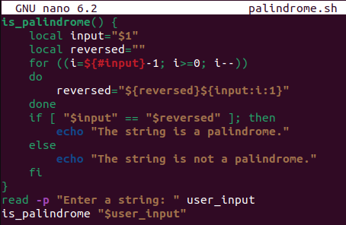
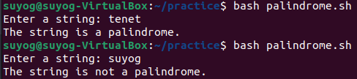
6) Write a shell script to print given number’s sum of all digits (eg. If number is 123, then it’s sum of all digits will be 1+2+3=6)
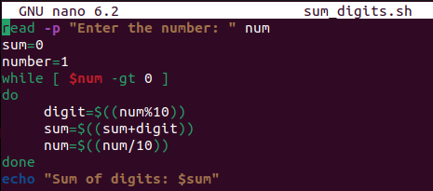
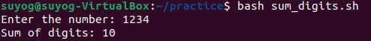

7) Create a script to
Create user , Delete user , Create group , delete Group using case
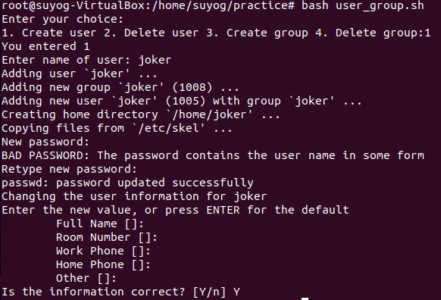
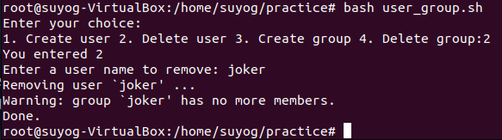
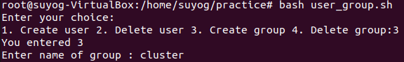

one
apple
banana
cat
dog
elephant
two
fish
gun
horse
icecream
three
jelly
kitkat
lolipop
marshmallow
four
new
oppo
vivo
china
/home -> mkdir EVERYONE
chmod 777 EVERYONE
Create a file with every user (whoami >> username.txt)
oppo -> primary group change -> one
vivo -> primary group change -> two
jelly,kitkat, lolipop, marshmallow -> add these users to sudo group

fish,gun -> add these users to one group as well (secondary group)
